**Team Seven - React.js Review Questions**

**(Answer key at the end)**

1. What does JSX compile down to?
   1. HTML tags
   2. React.createElement() calls
   3. a String
   4. It does not compile.
2. Assume “root” is a DOM node already in the tree. What, if anything, is wrong with this code?

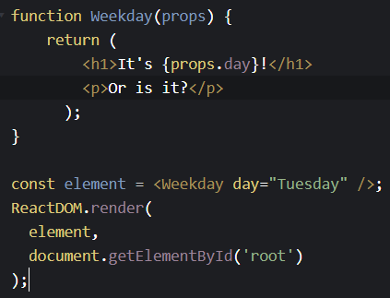

* 1. props.day does not need to be wrapped in curly braces
  2. Adjacent JSX elements (here h1 and p elements) must be wrapped in an enclosing tag
  3. A React element cannot represent a user-defined component (here Weekday)
  4. Nothing is wrong with this code

1. True or False. Once you create a React Element, you can change its children and attributes.
   1. True
   2. False
2. True or False. You are allowed to change the values of the props argument.
   1. True
   2. False
3. True or False: The state can not change in child Components.
   1. True
   2. False
4. Instead of trying to sync the state between different components, you should rely on the _____ data flow:
   1. Top-down
   2. Bottom-up
5. Event handling with React components is _________ event handling with DOM components.
   1. Different from
   2. Similar to
6. Lifecycle of React components is handled automatically by React and you do not need to worry about it.
   1. True
   2. False
7. Using Boolean conditions to render specific React elements is complex and requires some extra steps.
   1. True
   2. False
8. Vue supports both one-way data binding and two-way data binding.
   1. True
   2. False
9. React contains third-party packages for routing.
   1. True
   2. False

ANSWER KEY - SPOILERS AHEAD

1. B) React.createElement() calls
2. B) Adjacent JSX elements (here <h1> and <p> elements) must be wrapped in an enclosing tag such as <div>.
3. B) False
4. B) False
5. A) True
6. A) Top-down
7. B) Similar to
8. B) False
9. B) False
10. A) True
11. A) True